**SRI A.S.N.M.GOVERNMENT COLLEGE (A),PALAKOL**

(NAAC Re-Accredited with NAAC “B” Grade (CGPA 2.61)

WEST GODAVARI Dist., A.P., Pin.534260

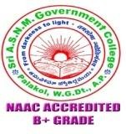

**DEPARTMENTOFBOTANY**

FIELD VISIT 22.03.2022

21-03-2022

Palakol

**To**

**The Principal**

**Sri A.S.N.M Govt. College (A),**

**Palakol, W.G. Dt.**

Madam,

Sub:- Sri A.S.N.M Govt Degree College(A), Palakol- Permission for a visit to Coringa Wildlife Sanctuary, Kakinada East Godavari district-Reg.

We would like to inform you that our B.Sc., (II & III CBZ) students were proposed to visit Coringa Wildlife Sanctuary at Korangi Village of Kakinada, East Godavari District along with the staff members of Biological Science (Botany & Zoology) as a part of their curriculum on Biodiversity subject. In this connection we request you to kindly grant us permission to visit Wildlife Sanctuary on 22/03/2022. The Incharge of Botany & Zoology Dr. M Ramakrishna, Dr. Y Vijay Kumar, Kum. P Jyotsna sri along with the students.

Thanking You

Yours faithfully,

Here with enclosing the signatures of staff members and students.

SRIA.S.N.M.GOVERNMENTCOLLEGE(A),PALAKOL, W.G.Dt

(NAAC Re-Accredited with NAAC “B” Grade (CGPA 2.61)

PALAKOL,WESTGODAVARIDist., A.P., Pin.534260



DEPARTMENTOFBOTANY

FIELD VISIT 22.03.2022

Sri A S N M GDC (A), PALAKOL Department of Botany conducted field visit to Coringa Wildlife Sanctuary at Korangi Village of Kakinada, East Godavari District along with the staff members of Biological Science (Botany & Zoology) as a part of their curriculum on Biodiversity subject. Dept of Botany Dr. Y Vijay kumar, Dept of Zoology Dr.M Ramakrishna, Kum. P Jyotsna sri have participated in this field trip, to get the knowledge about Bio diversity & its conservation.

Signature of the Faculty: 1.

2.

SRIA.S.N.M.GOVERNMENTCOLLEGE(A),PALAKOL, W.G.Dt

**DEPARTMENT OF BOTANY**

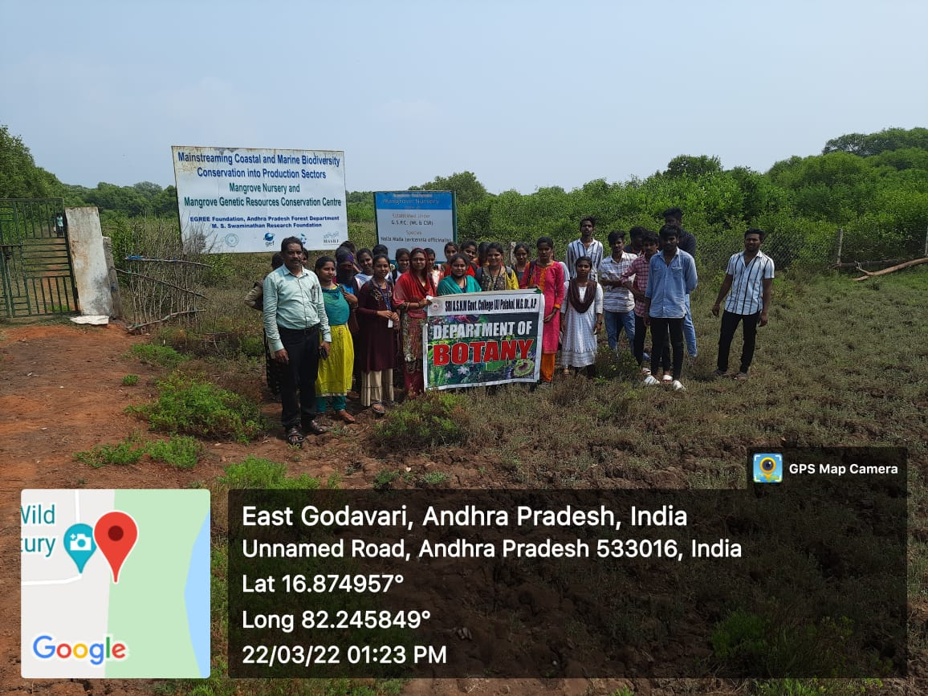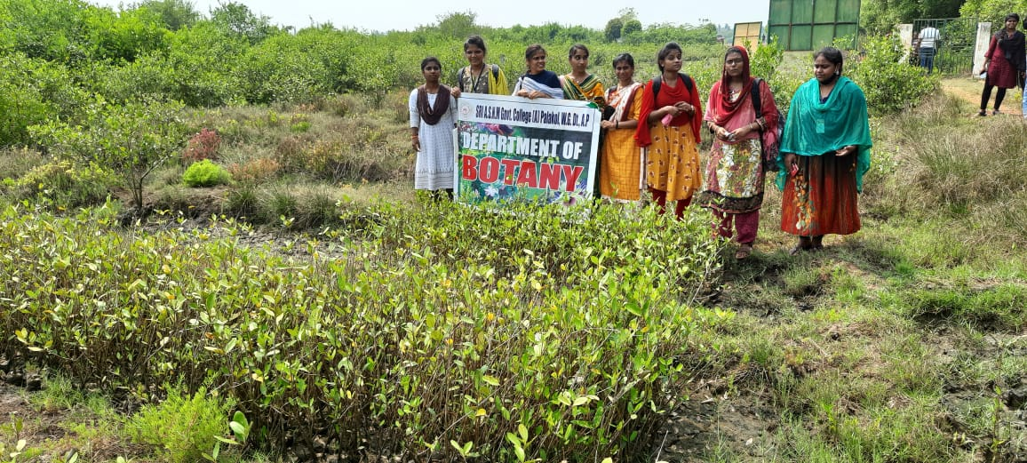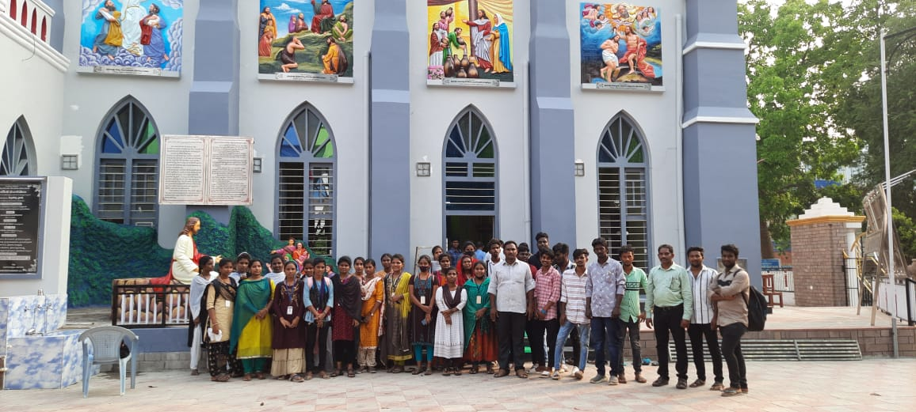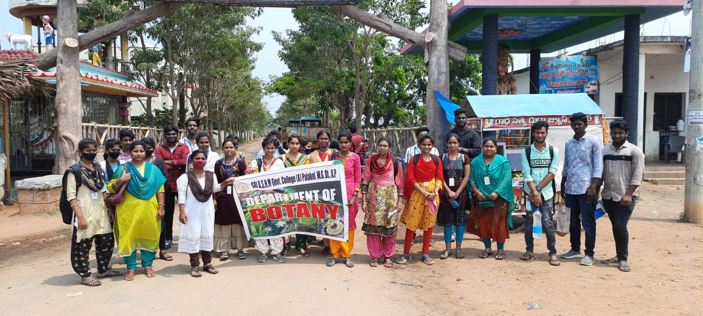FIELD VISIT:- CORINGA WILDLIFE SANCTUARY, KAKINADA 22-03-2022